What if Experiments Prairie:

1. The Experiment was to change the incoming flow of nutrients (in the model – J called nutrients) to a higher value than the given values: from .005 to .025; and compare to the natural state values.

The long term behavior of the grass and peat systems converges to roughly the same value. The grass/peat values rise much more rapidly the first few years but settle to a value that is only slightly higher than the natural growth values.

1. For this experiment I multiplied the outflow of peat by two in order to increase the amount of peat that was decomposed.

The amount of peat in the prairie diminishes to almost half of its previous settled value in the long run. The grass in the prairie is slightly affected by the lessened amount of peat to provide nutrients to the soil but its long term value is not greatly affected, only slightly less.

1. For this experiment I set the value of constant K4 to be 0 to signify no outflow of nutrients from the system by the stream.

The effect of blocking off the stream has a very similar effect to the first part where we added nutrients to the system. The asymptote of the growth of peat and grass is still roughly the same as the natural case and the added sewage from part one. We see that over the long term the only thing that causes the largest change in long term effects is the change in the death rates of peat. But even then grass populations did not fluctuate much. Also, this experiment caused the nutrients of the system to not decrease as rapidly and therefore it was a continuously increasing quantity.

APENDIX:

Figure 1: is a reproduction in my simulation of the given plots, with the given constants

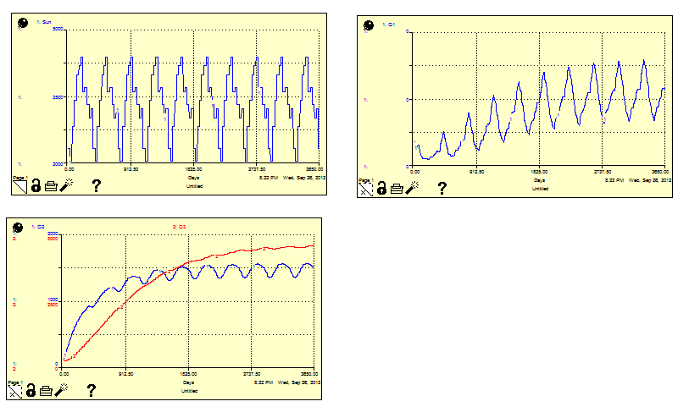

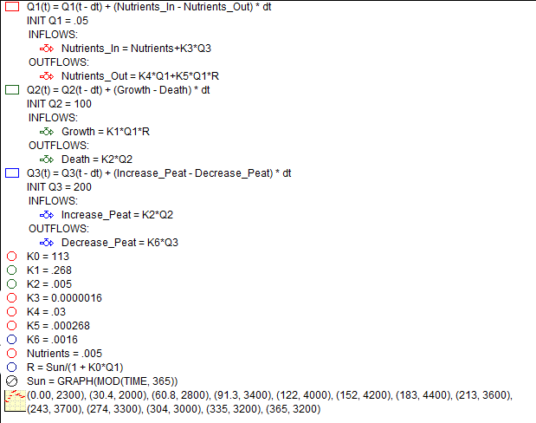Figure 2: the equations describing the simulation.

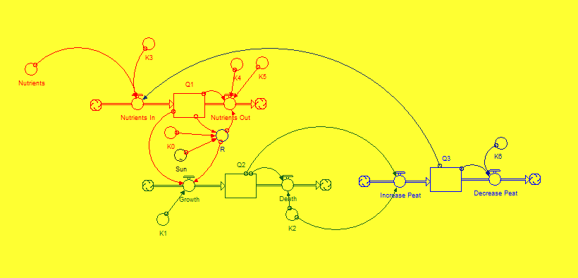

Figure 3: The model for the simulations